Taylor Cowley

Lab 04: CAD Schematic Entry and Simulation

May 12 2016

|  |  |  |  |  |  |  |  |  |  |  |  |
| --- | --- | --- | --- | --- | --- | --- | --- | --- | --- | --- | --- |
| **Input** | | | | **(total)** | **Output** | | | | | | |
| **N3** | **N2** | **N1** | **N0** |  | **a** | **b** | **c** | **d** | **e** | **f** | **g** |
| 0 | 0 | 0 | 0 | 0 | 0 | 0 | 0 | 0 | 0 | 0 | 1 |
| 0 | 0 | 0 | 1 | 1 | 1 | 0 | 0 | 1 | 1 | 1 | 1 |
| 0 | 0 | 1 | 0 | 2 | 0 | 0 | 1 | 0 | 0 | 1 | 0 |
| 0 | 0 | 1 | 1 | 3 | 0 | 0 | 0 | 0 | 1 | 1 | 0 |
| 0 | 1 | 0 | 0 | 4 | 1 | 0 | 0 | 1 | 1 | 0 | 0 |
| 0 | 1 | 0 | 1 | 5 | 0 | 1 | 0 | 0 | 1 | 0 | 0 |
| 0 | 1 | 1 | 0 | 6 | 0 | 1 | 0 | 0 | 0 | 0 | 0 |
| 0 | 1 | 1 | 1 | 7 | 0 | 0 | 0 | 1 | 1 | 1 | 1 |
| 1 | 0 | 0 | 0 | 8 | 0 | 0 | 0 | 0 | 0 | 0 | 0 |
| 1 | 0 | 0 | 1 | 9 | 0 | 0 | 0 | 0 | 1 | 0 | 0 |
| 1 | 0 | 1 | 0 | A | 0 | 0 | 0 | 1 | 0 | 0 | 0 |
| 1 | 0 | 1 | 1 | b | 1 | 1 | 0 | 0 | 0 | 0 | 0 |
| 1 | 1 | 0 | 0 | C | 0 | 1 | 1 | 0 | 0 | 0 | 1 |
| 1 | 1 | 0 | 1 | d | 1 | 0 | 0 | 0 | 0 | 1 | 0 |
| 1 | 1 | 1 | 0 | E | 0 | 1 | 1 | 0 | 0 | 0 | 0 |
| 1 | 1 | 1 | 1 | F | 0 | 1 | 1 | 1 | 0 | 0 | 0 |
|  |  |  |  |  | 2812 | D860 | 9004 | 8492 | 02BA | 208E | 1083 |
| **High Asserted** | | | |  | **Low Asserted** | | | | | | |

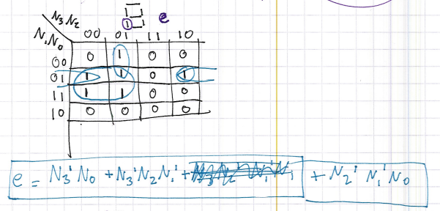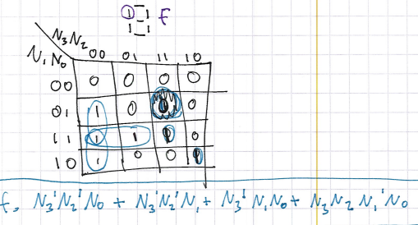

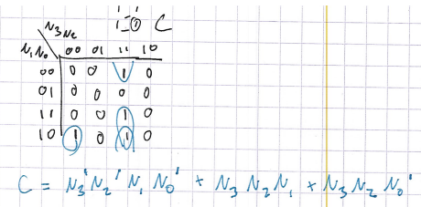

Procedure

ROM schematic and Combinational Logic Schematic

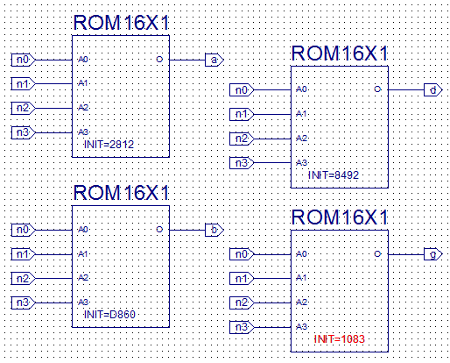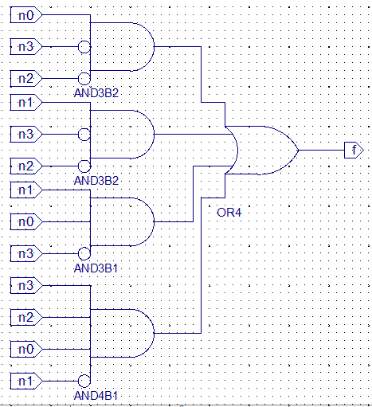

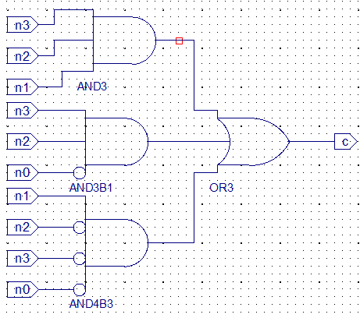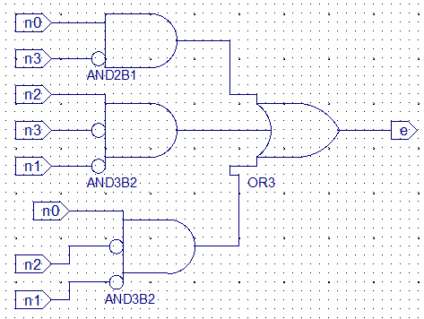

Seven Segment Decoder Schematic

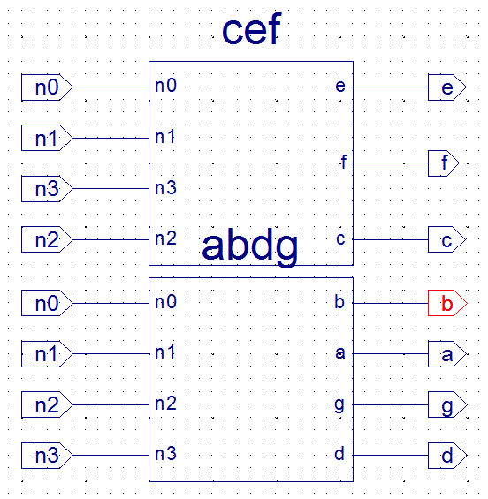

TCL File for simulation

isim force add n3 0

isim force add n2 0

isim force add n1 0

isim force add n0 0

run 5ns

isim force add n0 1

run 5ns

isim force add n1 1

isim force add n0 0

run 5ns

isim force add n0 1

run 5ns

isim force add n2 1

isim force add n1 0

isim force add n0 0

run 5ns

isim force add n0 1

run 5ns

isim force add n1 1

isim force add n0 0

run 5ns

isim force add n0 1

run 5ns

isim force add n3 1

isim force add n2 0

isim force add n1 0

isim force add n0 0

run 5ns

isim force add n0 1

run 5ns

isim force add n1 1

isim force add n0 0

run 5ns

isim force add n0 1

run 5ns

isim force add n2 1

isim force add n1 0

isim force add n0 0

run 5ns

isim force add n0 1

run 5ns

isim force add n1 1

isim force add n0 0

run 5ns

isim force add n0 1

run 5ns

Simulation waveform for top-level seven-segment schematic

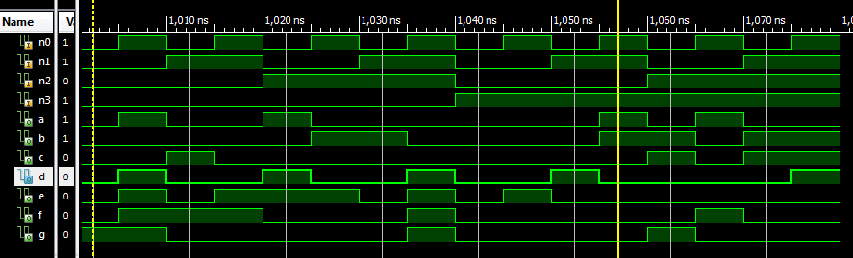

**Test Bench Schematic**

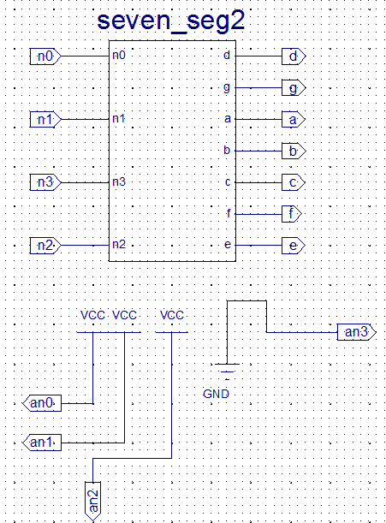

**Test Bench UCF**

## Switches

NET "n0" LOC = "L14";

NET "n1" LOC = "L13";

NET "n2" LOC = "N17";

NET "n3" LOC = "R17";

## 7 segment display

NET "a" LOC = "L18";

NET "b" LOC = "F18";

NET "c" LOC = "D17";

NET "d" LOC = "D16";

NET "e" LOC = "G14";

NET "f" LOC = "J17";

NET "g" LOC = "H14";

NET "an0" LOC = "F17";

NET "an1" LOC = "H17";

NET "an2" LOC = "C18";

NET "an3" LOC = "F15";

**Anomalies (bugs, problems, and suggestions)(5pts possible)**

Well the first time I did the K-maps, I did it all correct, but I did not implement the schematic according to the k-map. So I had to redo the schematic. Also, I got confused on how to initialize the ROM to the proper value- I was reading the truth table backwards to make the Hexadecimal values.